

Internal Memorandum

**To: CIO**

**CC:** n/a

**From:** Team B

**Date:** 10/21/2018

**Memo #:** 004

**Re:** Inject 004

CIO;

Here are scans from all of our machines, with completed scans and results

* 192.168.50.204 - Server 2008 - Nothing was found

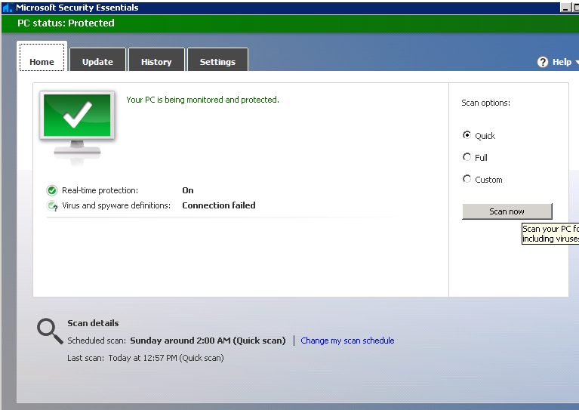

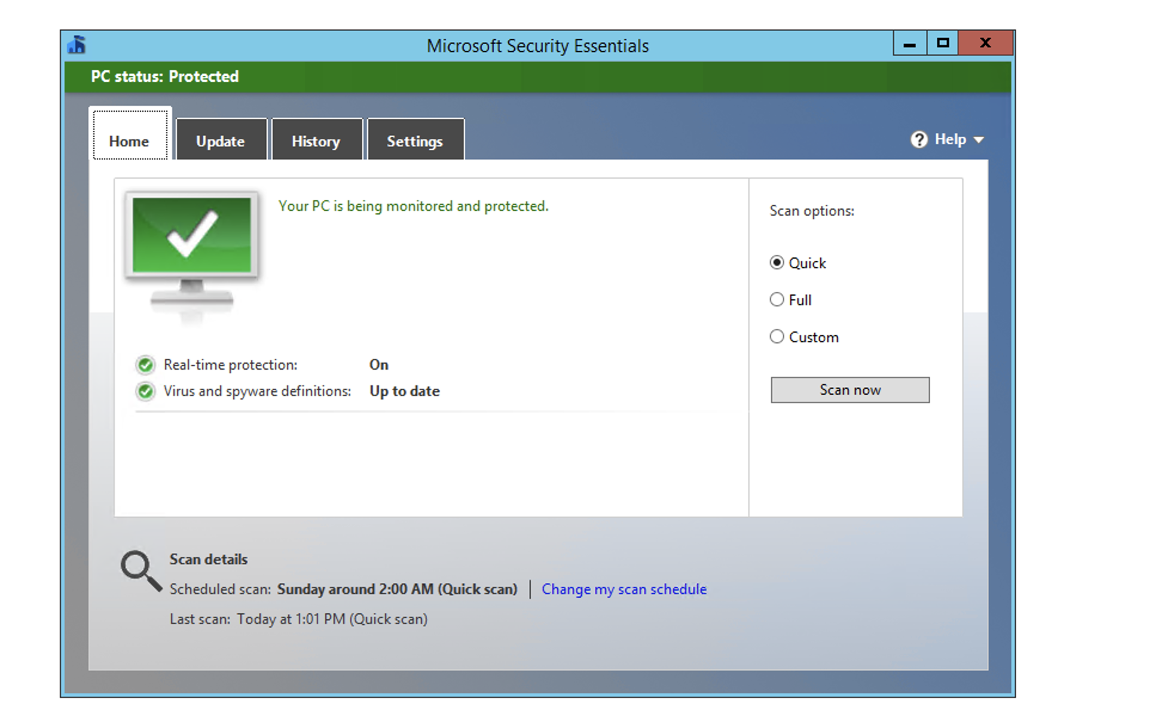

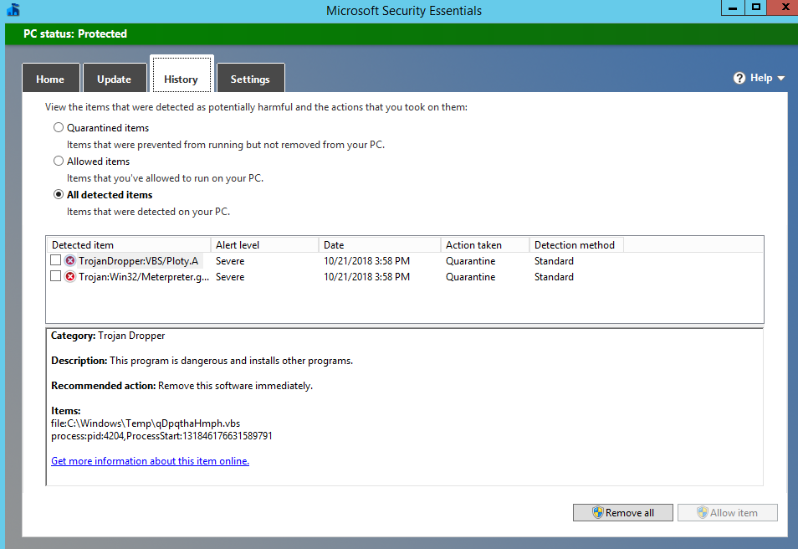

Above 192.168.50.206 - 2 Malicious items found. -Ibeh